
Presenting SQL Results
Career Foundry

December 17, 2024
Rockbuster
Jordan Novelli

TABLE OF CONTENTS
Table of Contents …………………………………………………………………………………………………1
Schema……………….………………………………………………………………………………………………2
Fact Table Description...…………………………………………………………………………………………2
Fact Table/Dimension Table……………………………………………………………………………………3
Tables needed to Answer Questions…………………………………………………………………………4

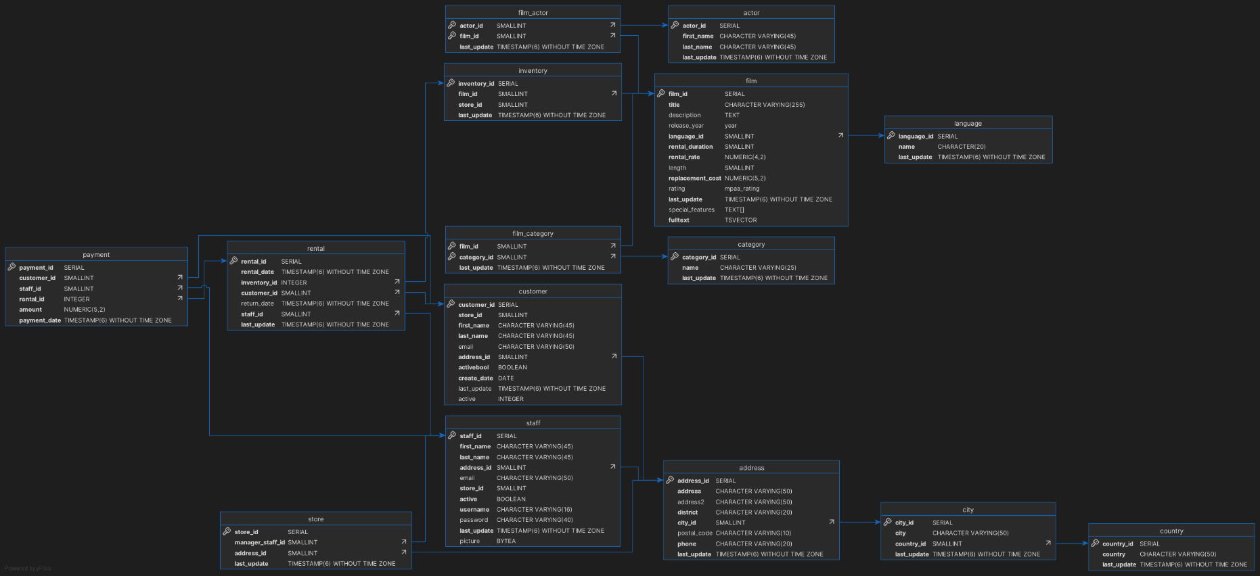
Data Storage & Structure - Answers 3.2

STEP 3:
- The Rockbuster database schema appears as a star.
- Fact table for the Rockbuster database would more than likely be the Rental table. As you can get to all other tables from that table alone.

    - Fact Table
COLUMN | DATA TYPE | Links To/From | Unique Key | DESCRIPTION
Payments | Serial | LINKS TO: Rental, Customer, Staff  LINKS FROM: N/A | Payment_id | Records payments by customers and the staff member who processed it.
Film Actor | SmallInt | LINKS TO: Actor, Film  LINKS FROM: N/A | Actor_id, film_id | Records the actors in each film
Inventory | Serial | LINKS TO: Film  LINKS FROM: Rental | Inventory_id | Records the inventory within the store and the films within it
Store | Serial | LINKS TO: Staff, Address  LINKS FROM: N/A | Store_id | Records the address and management of the store
Film Category | SmallInt | LINKS TO: Film, Category  LINKS FROM: N/A | Film_id, category_id | Records the categories of the films in the store.

    - Dimension Table
COLUMN | DATA TYPE | Links To/From | Unique Key | DESCRIPTION
Rental | Serial | LINKS TO: Inventory, Customer, Staff  LINKS FROM: Payment | Rental_id | Records the films rented by customers and processes the inventory in the store.
Customer | Serial | LINKS TO: Address  LINKS FROM: Rental, Payment | Customer_id | Records the data bases created for the customers that rent from the store
Staff | Serial | LINKS TO: Address  LINKS FROM: Rental, Store, Payment | Staff_id | Records the staff information for employees at the store
Film | Serial | LINKS TO: Language  LINKS FROM: Film_Actor, Inventory, Film_Category | Film_id | Records the Language, duration, rental rate, title, release year and description of the film.
Address | Serial | LINKS TO: City  LINKS FROM: Store, Staff, Customer | Address_id | Records the addresses of the staff/customers
City | Serial | LINKS TO: Country  LINKS FROM: Address | City_id | Records the city of staff/customers
Country | Serial | LINKS TO: N/A  LINKS FROM: City | Country_id | Records the country of staff/customers
Language | Serial | LINKS TO: N/A  LINKS FROM: Film | Language_id | Languages of the films in the store.
STEP 4:
- Which actors brought Rockbuster the most revenue?
  - You’d need the Film Actor, Actor, Film tables. In these tables you could find the actor and the rental rate.
- What language are the majority of movies in the collection?
  - You’d need the Film and Language table to determine the majority language of the movies.

